IT Asset Management System — ServiceNow

Application Modules
Custom tables are created to store and manage IT asset information and related activities. The application includes Asset, Asset Request, Asset Assignment, Asset Maintenance, and Asset Return tables. These tables help track assets throughout their lifecycle.

1. Asset
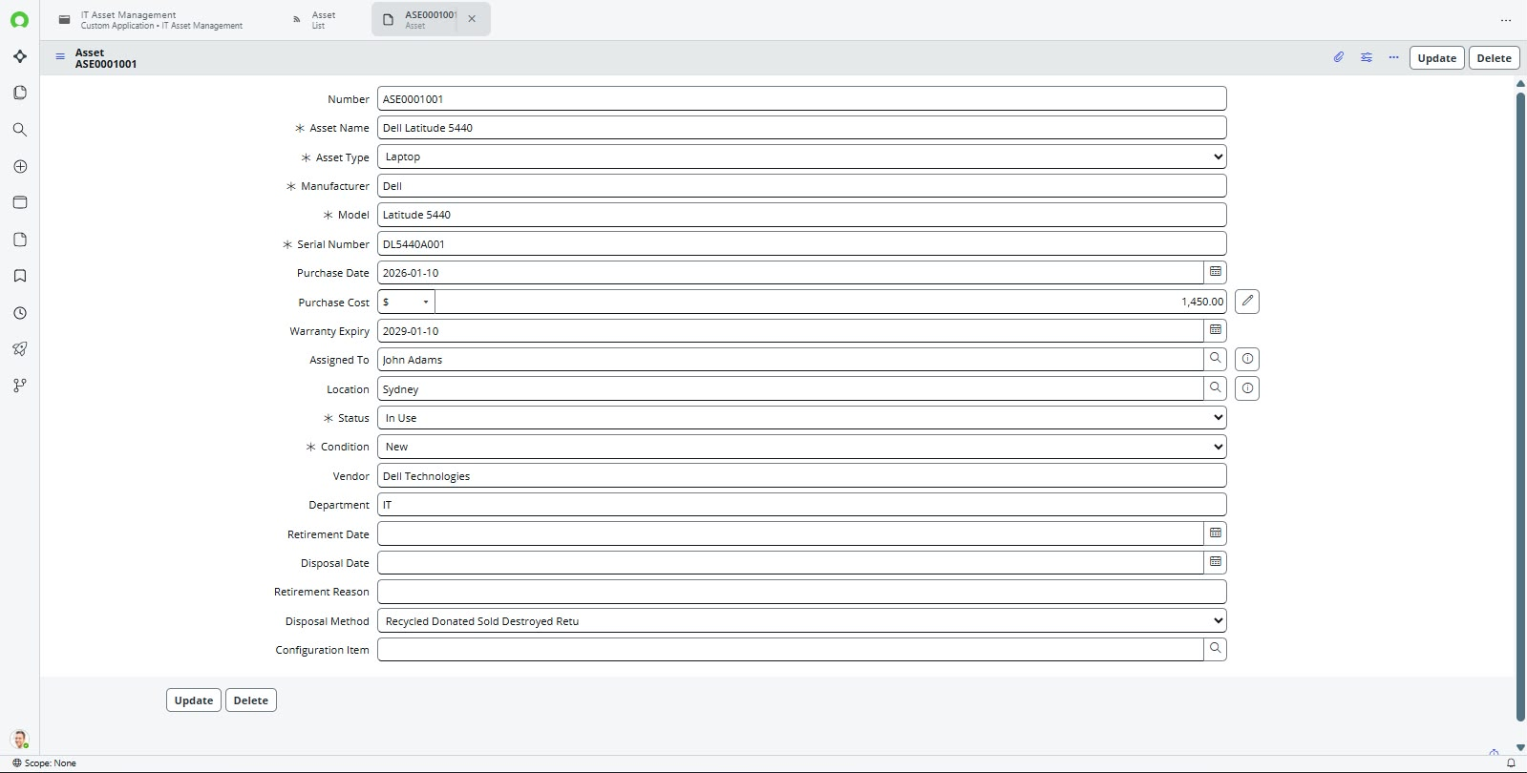

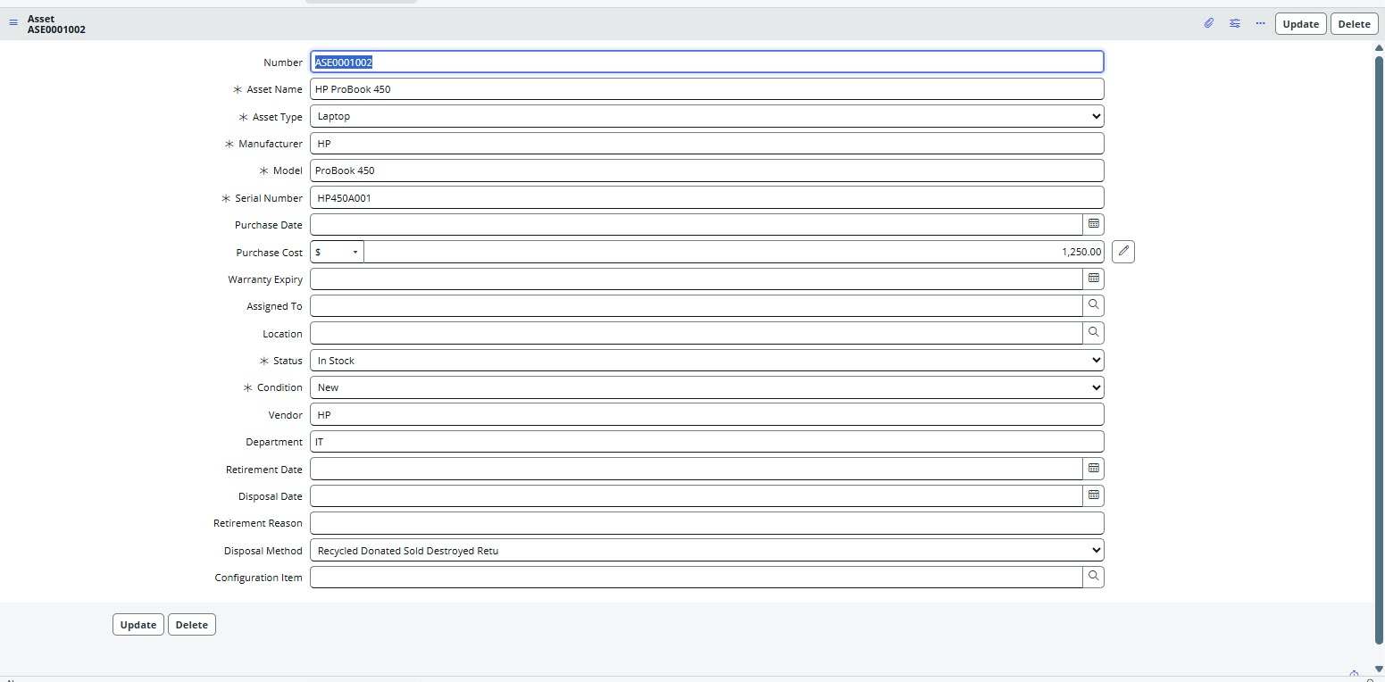

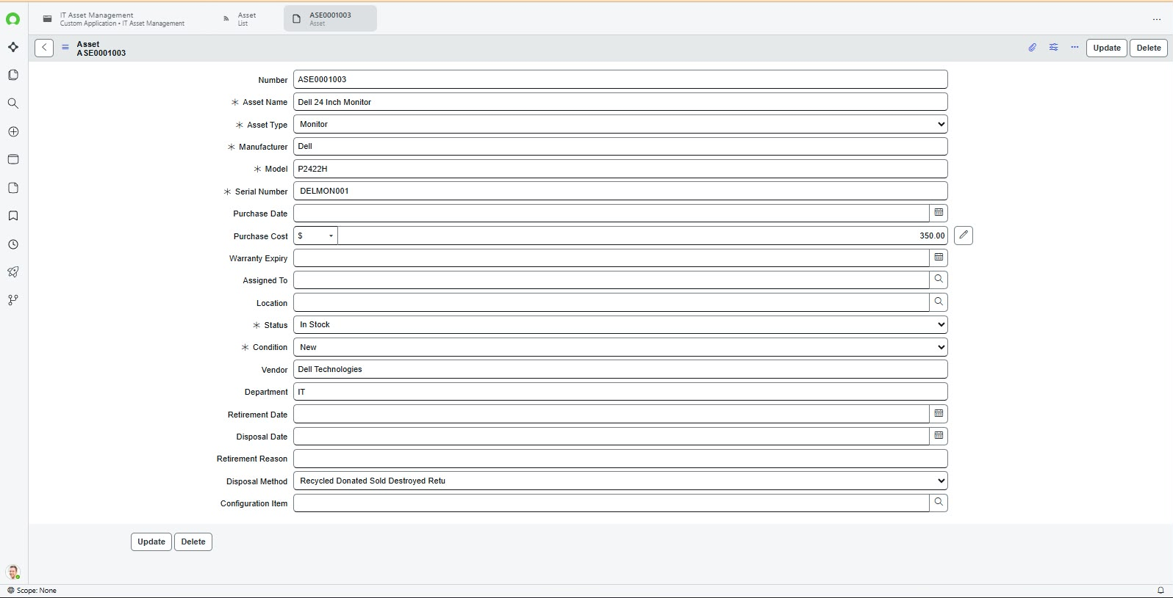

2. Asset Request
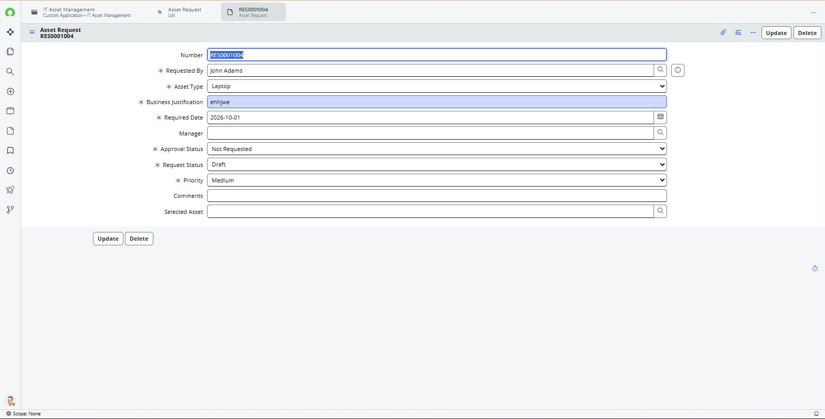

3. Asset Assignment
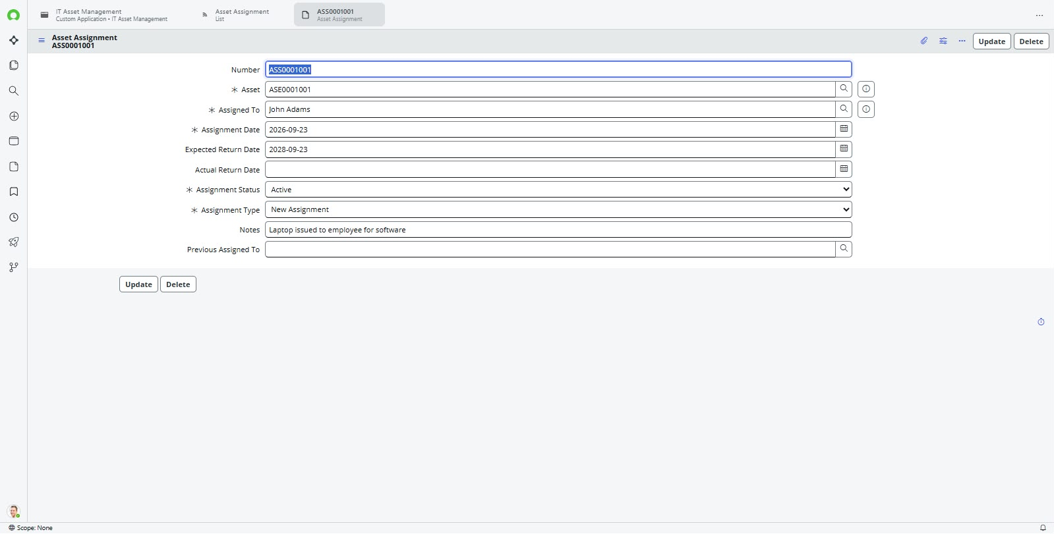

4.Asset Return
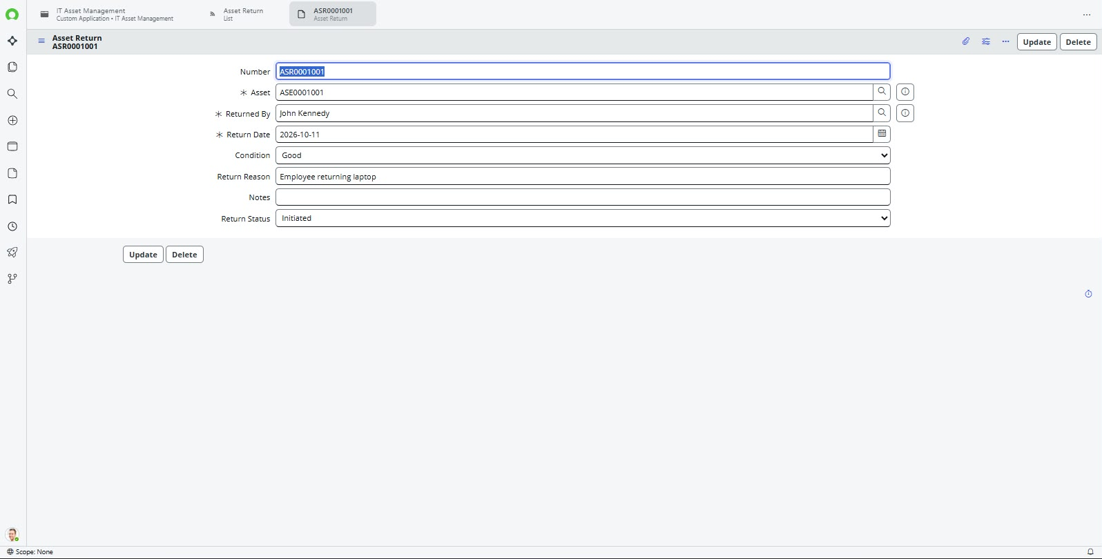

5.Asset Maintenance
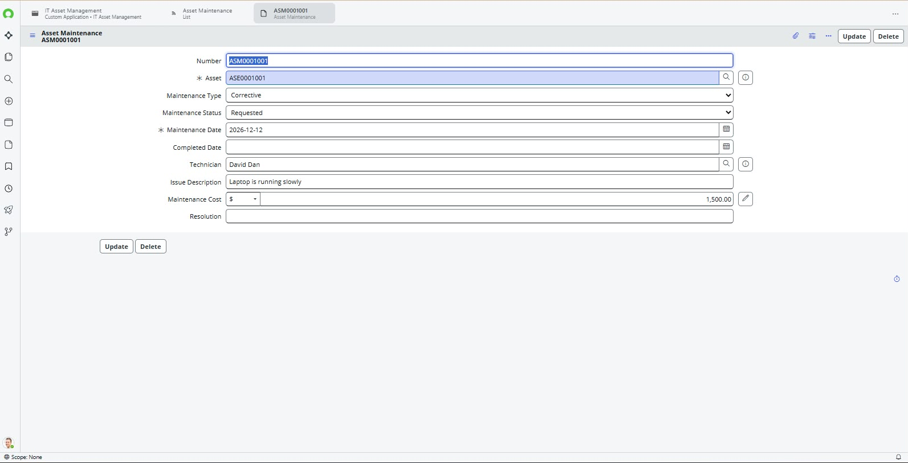

Flow Designer
1.Manager Approval
Flow Designer automates asset management processes with minimal manual intervention. It is used to manage manager approvals and automate asset allocation based on asset type and availability.

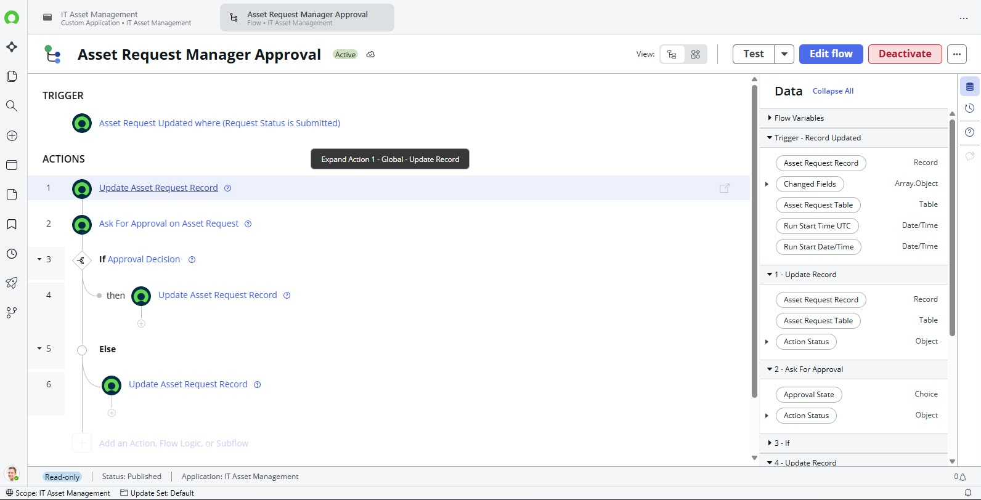

2. Automatic Asset Allocation

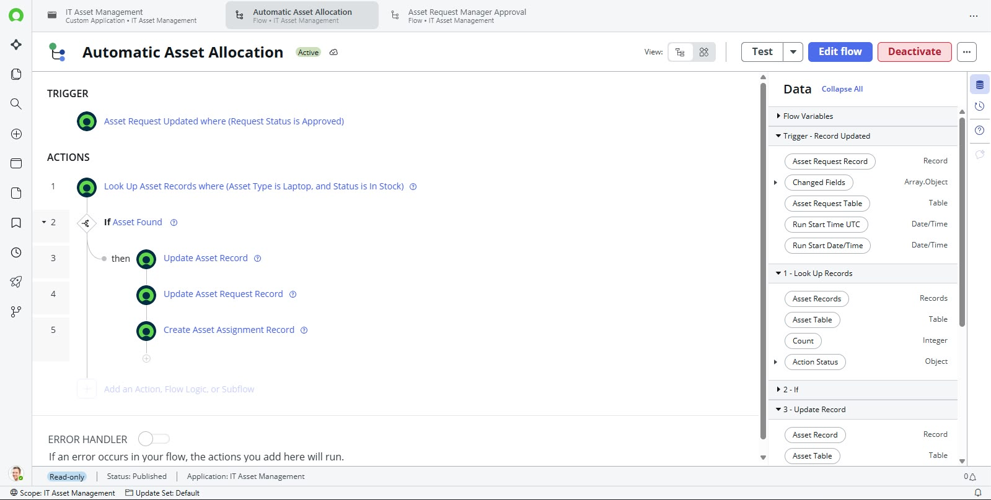

Business Rules
Business Rules execute server-side logic when specified record operations or conditions occur. They help prevent duplicate active assignments and update asset information during assignment, return, maintenance, retirement, and disposal processes.

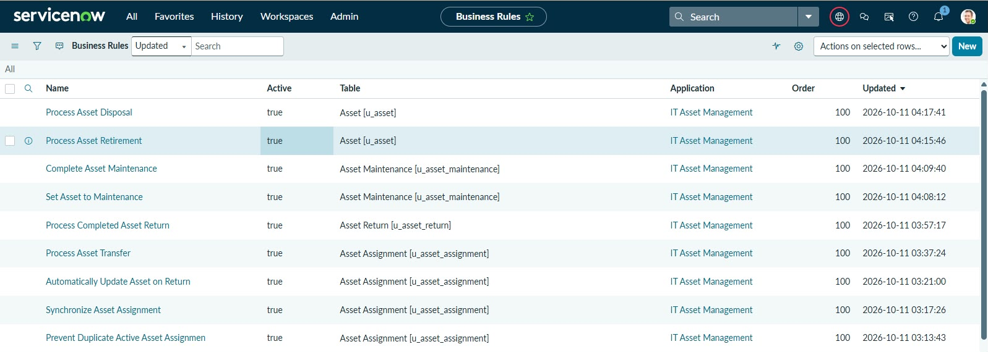
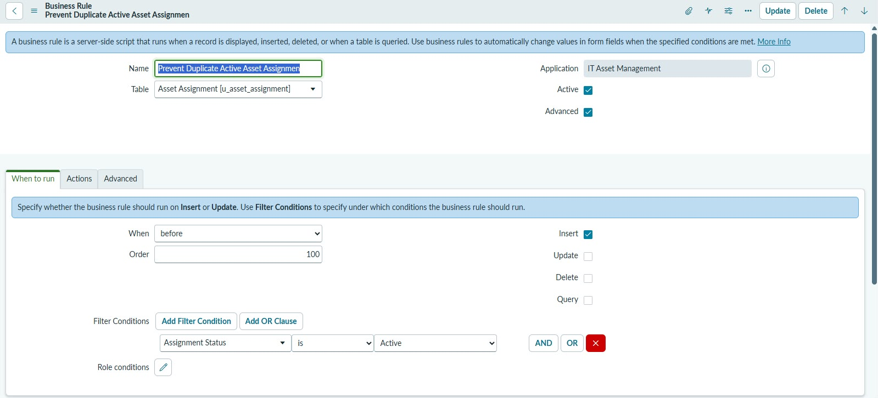
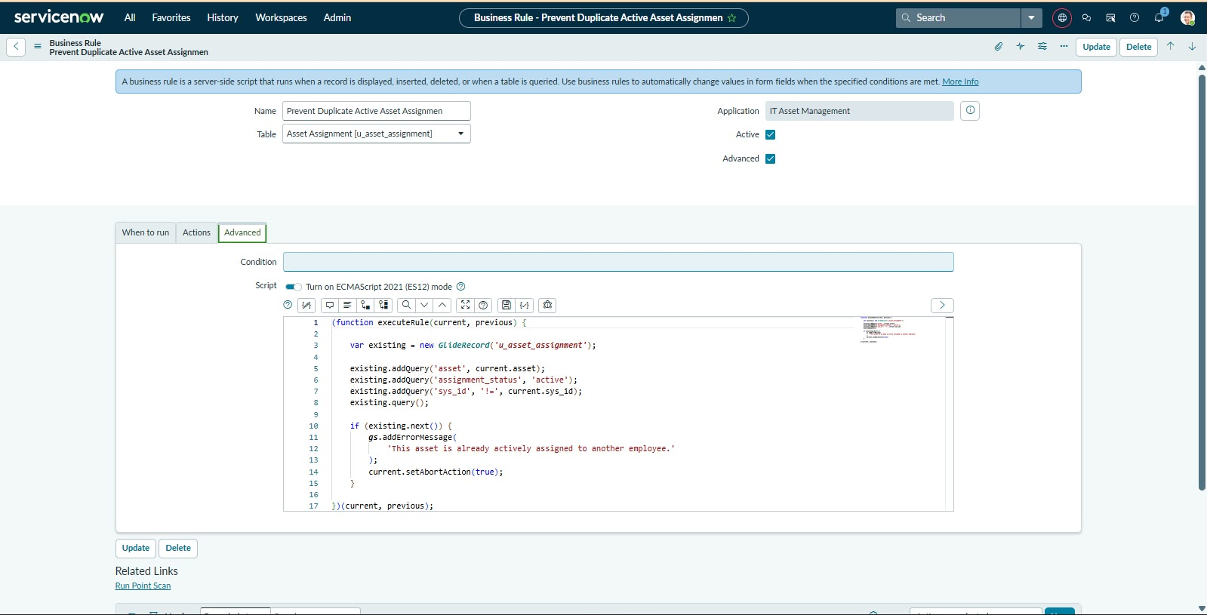
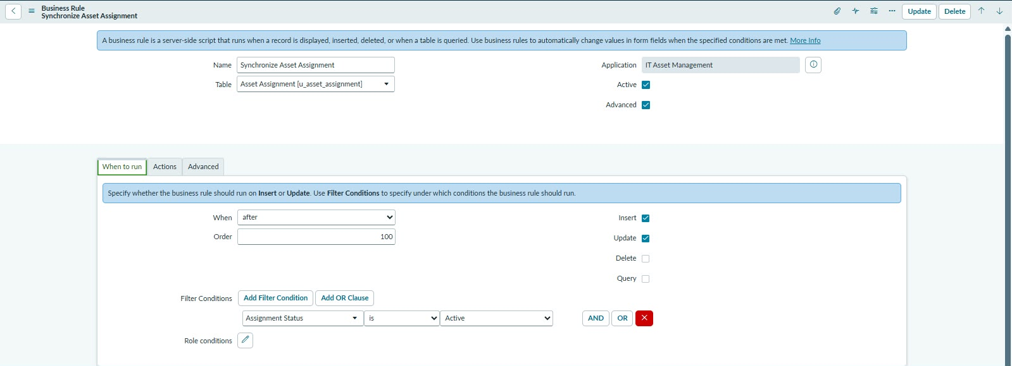
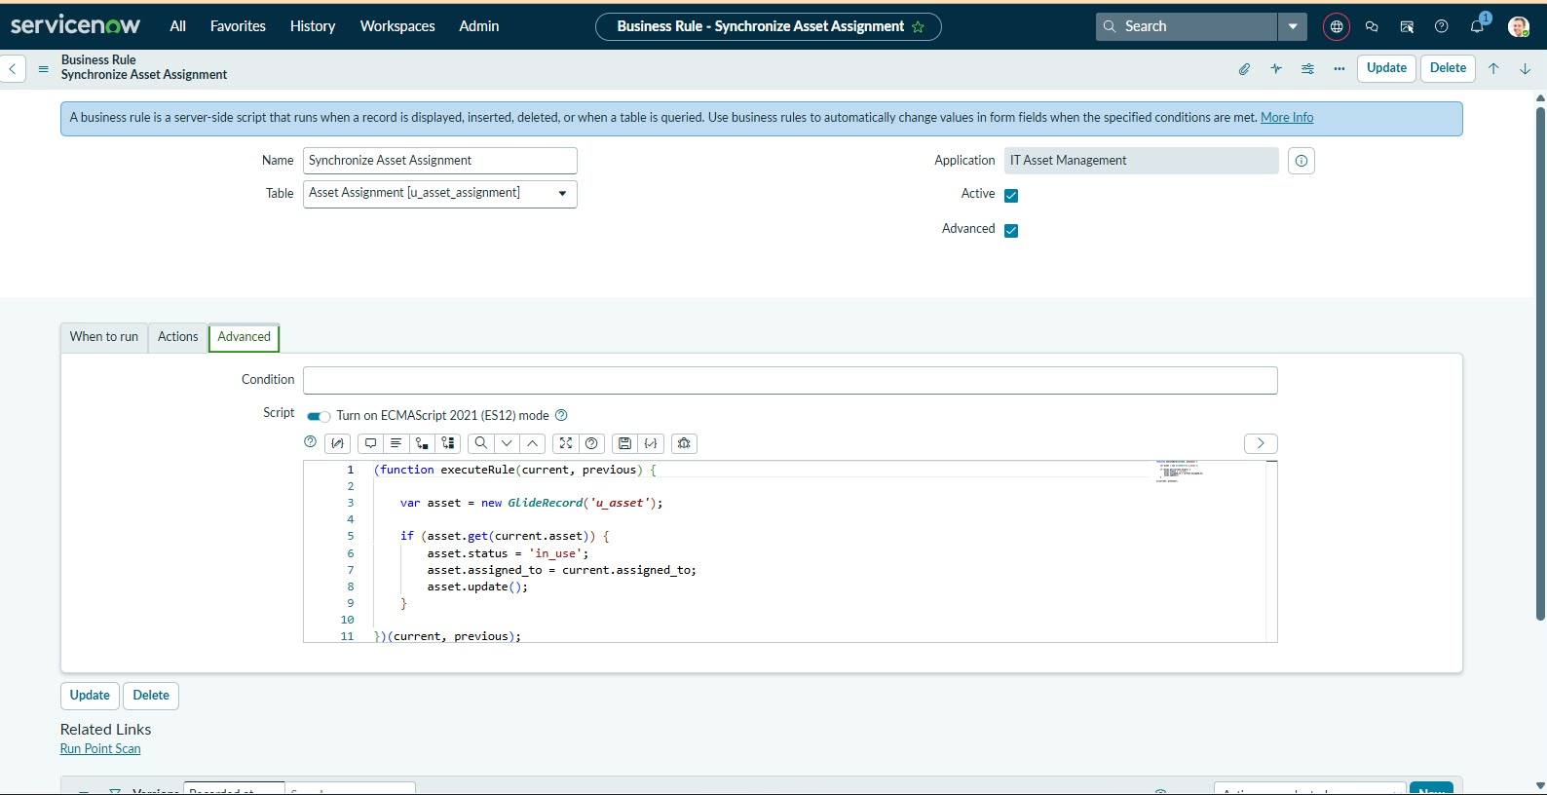
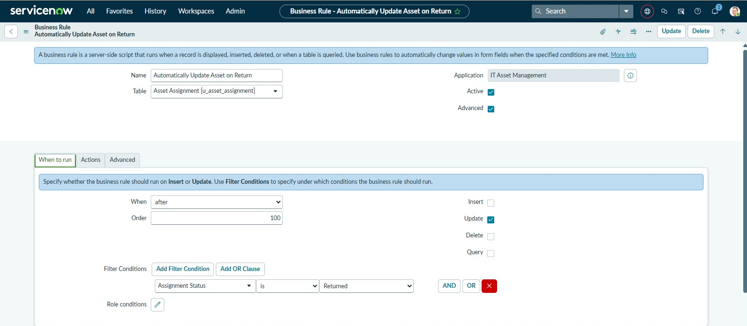
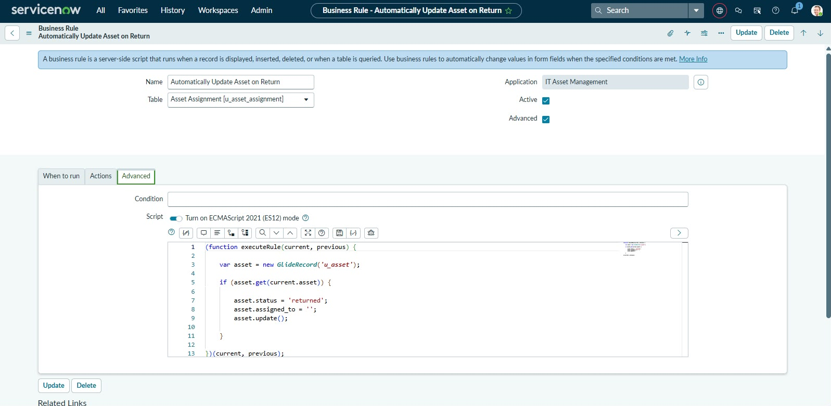
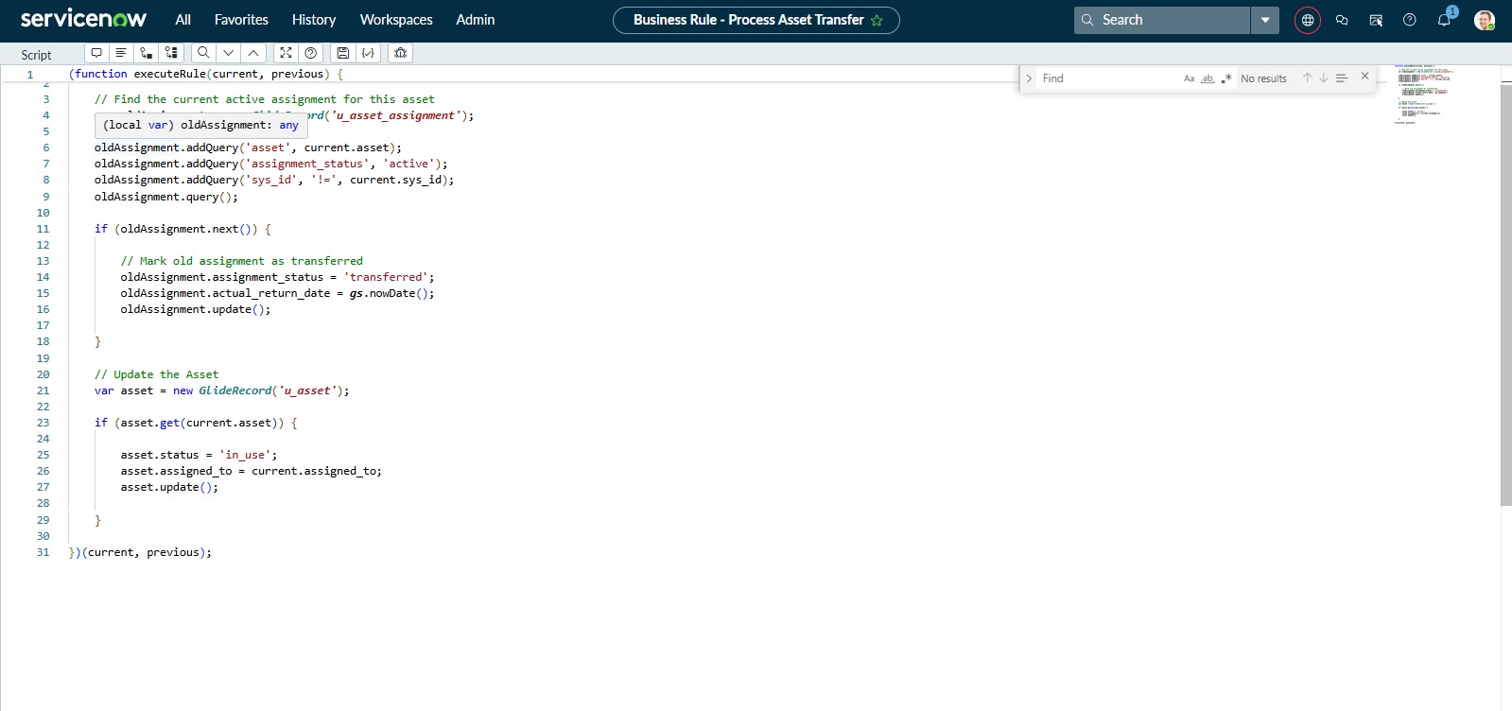
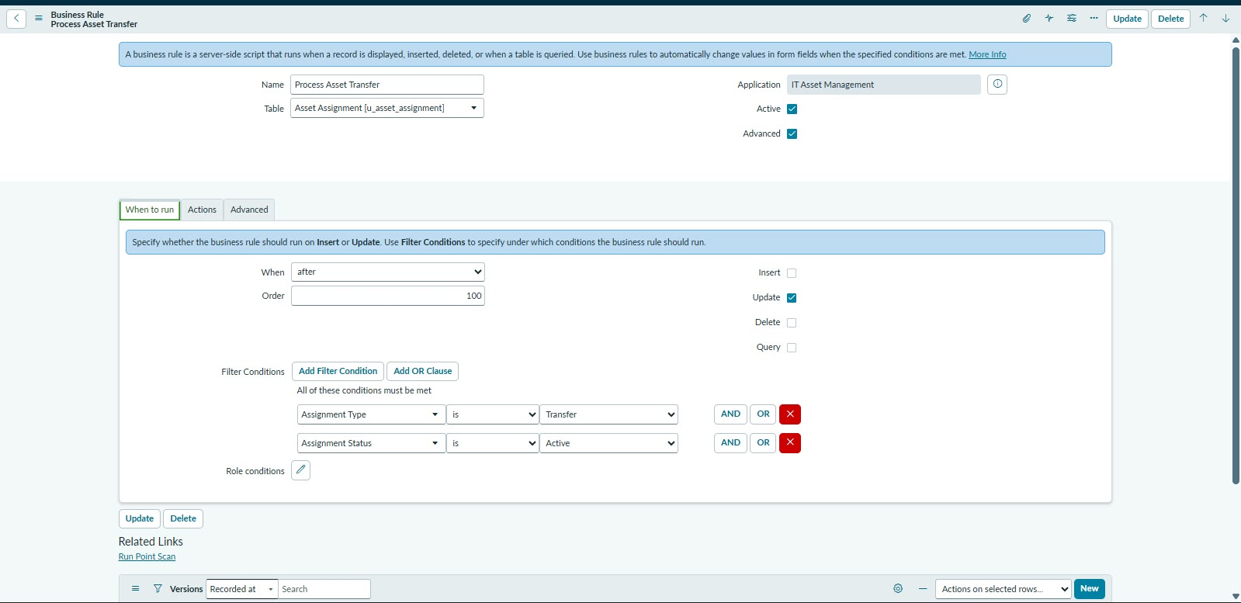
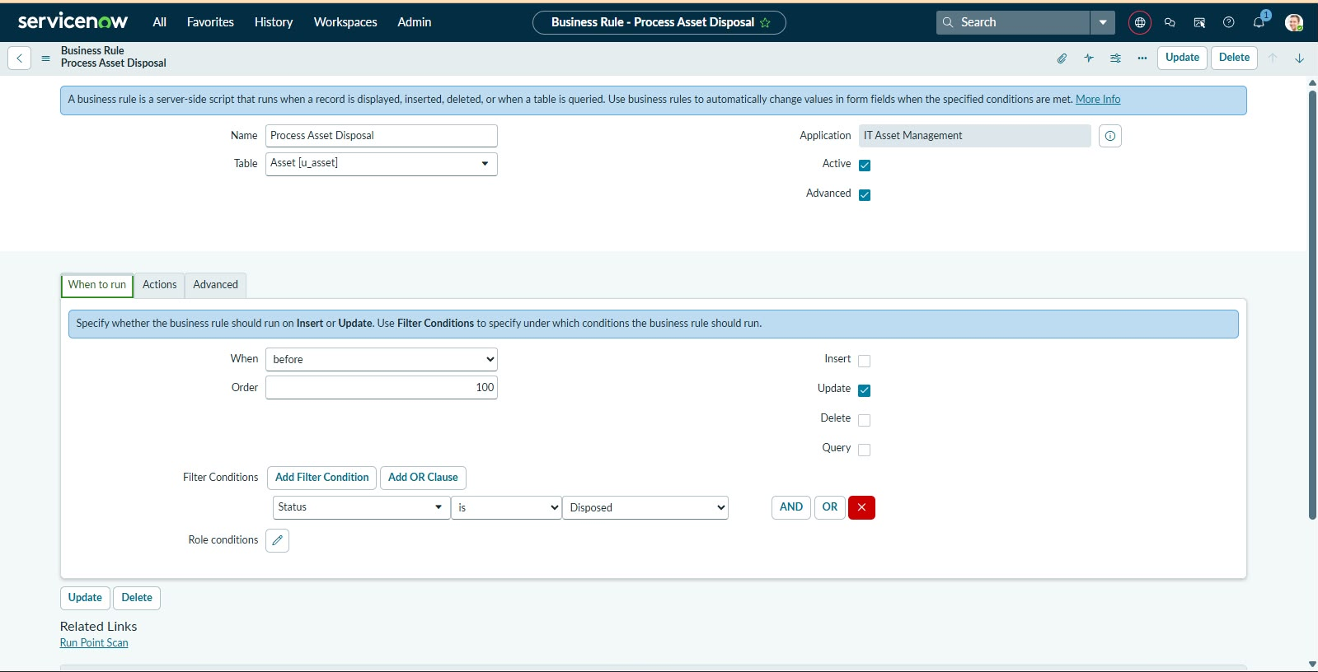
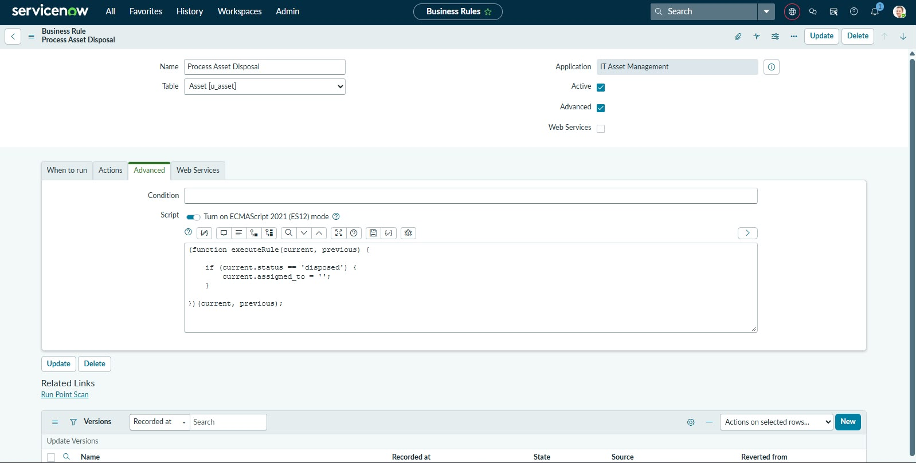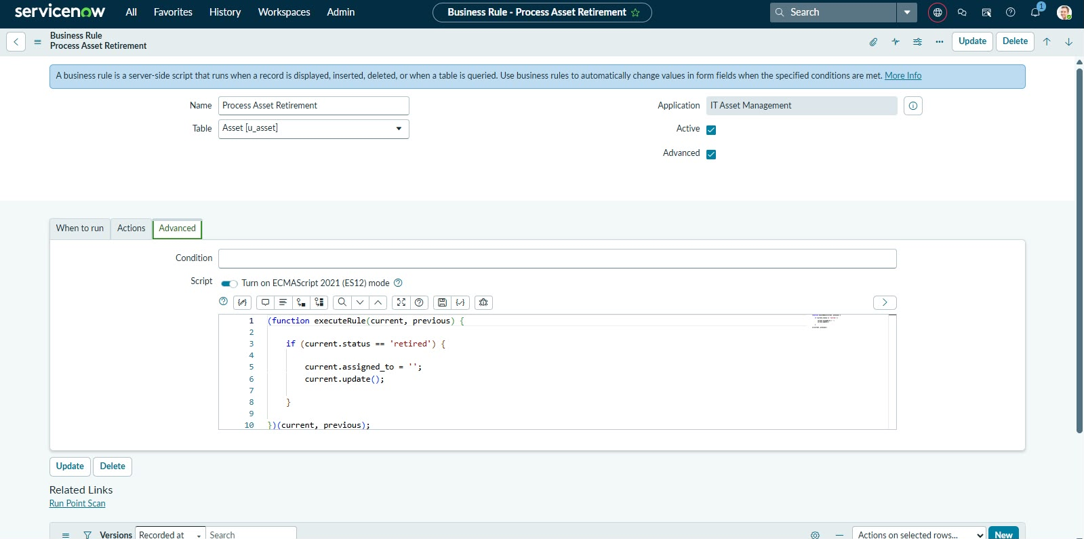
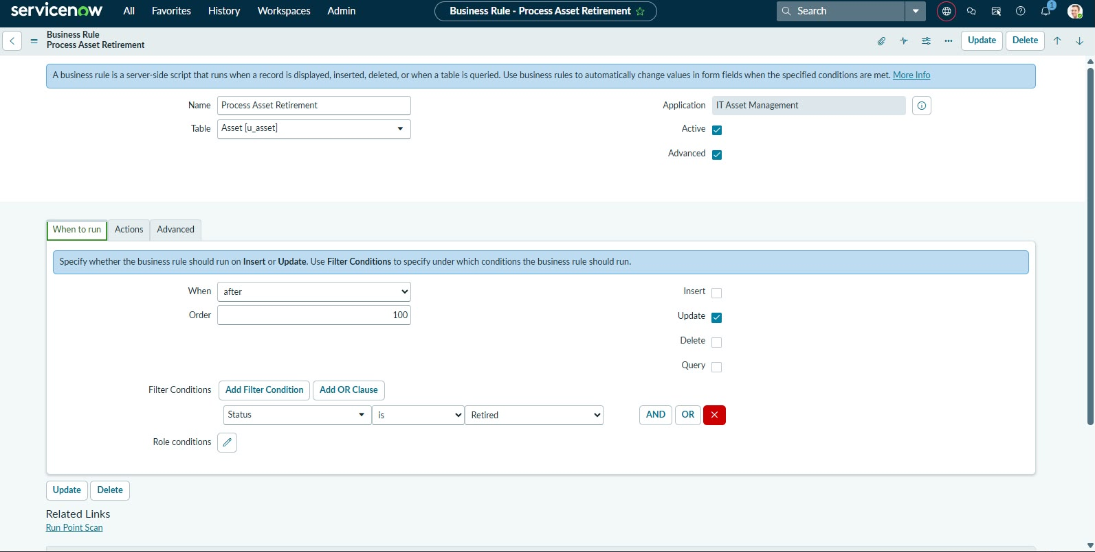
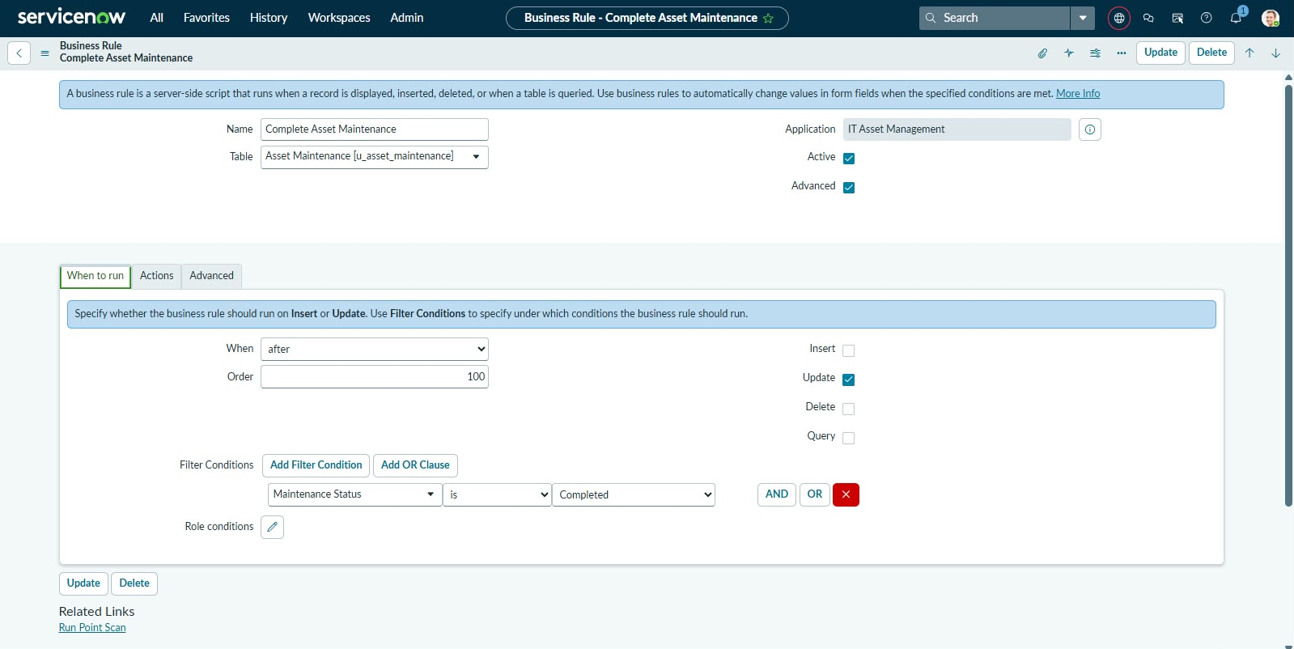
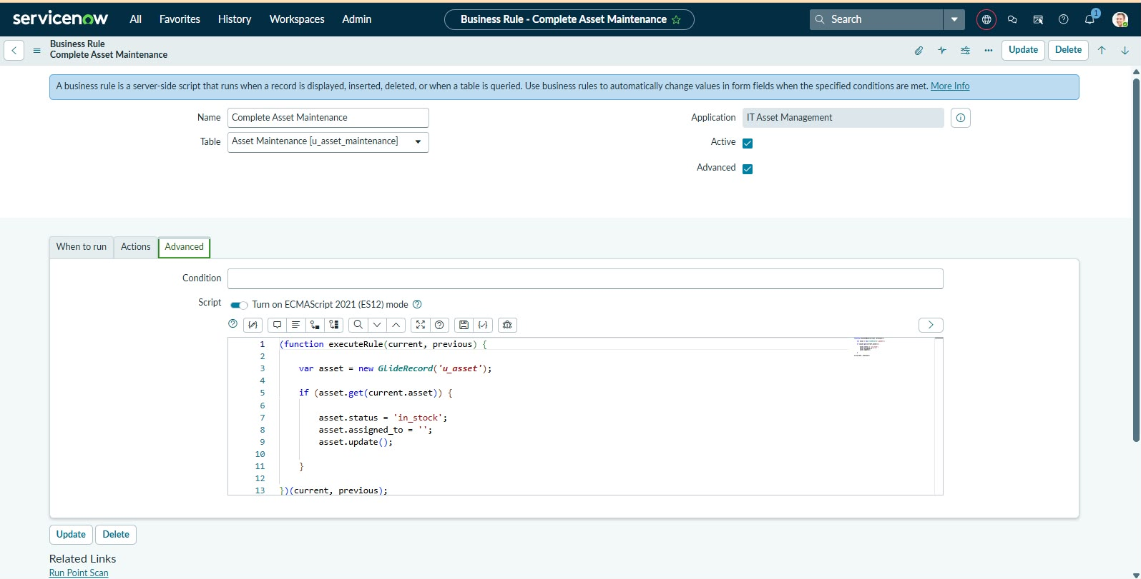
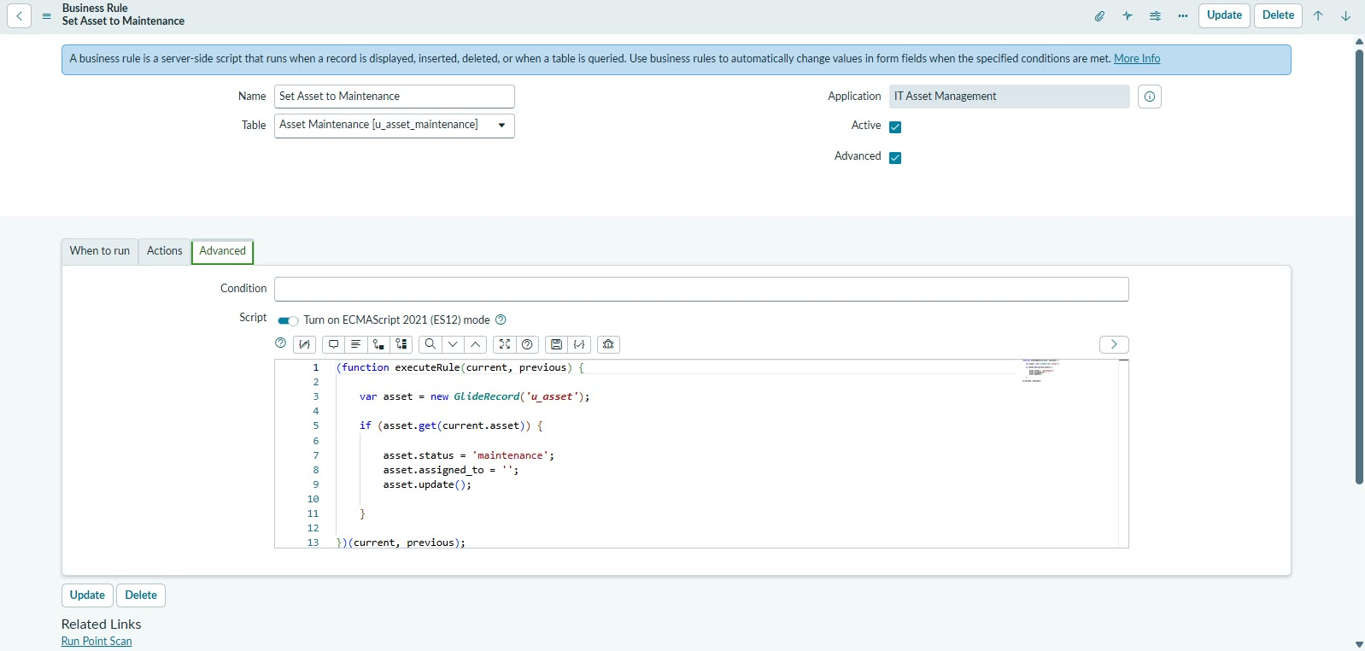
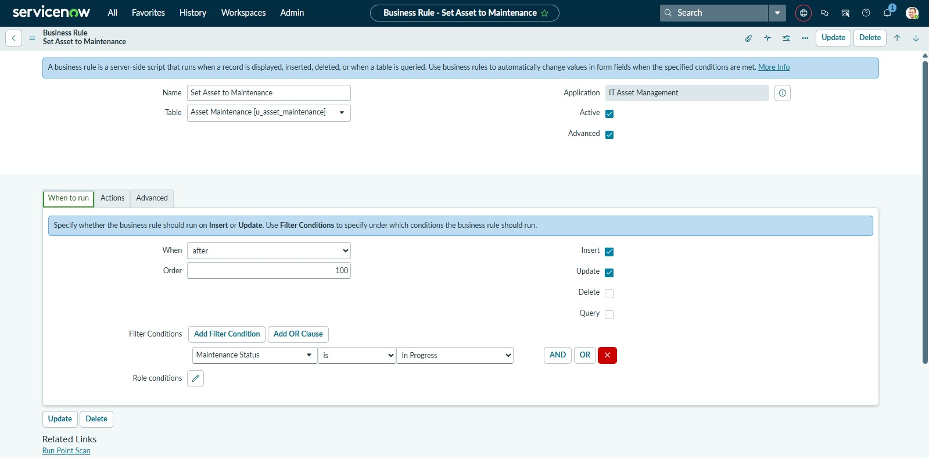
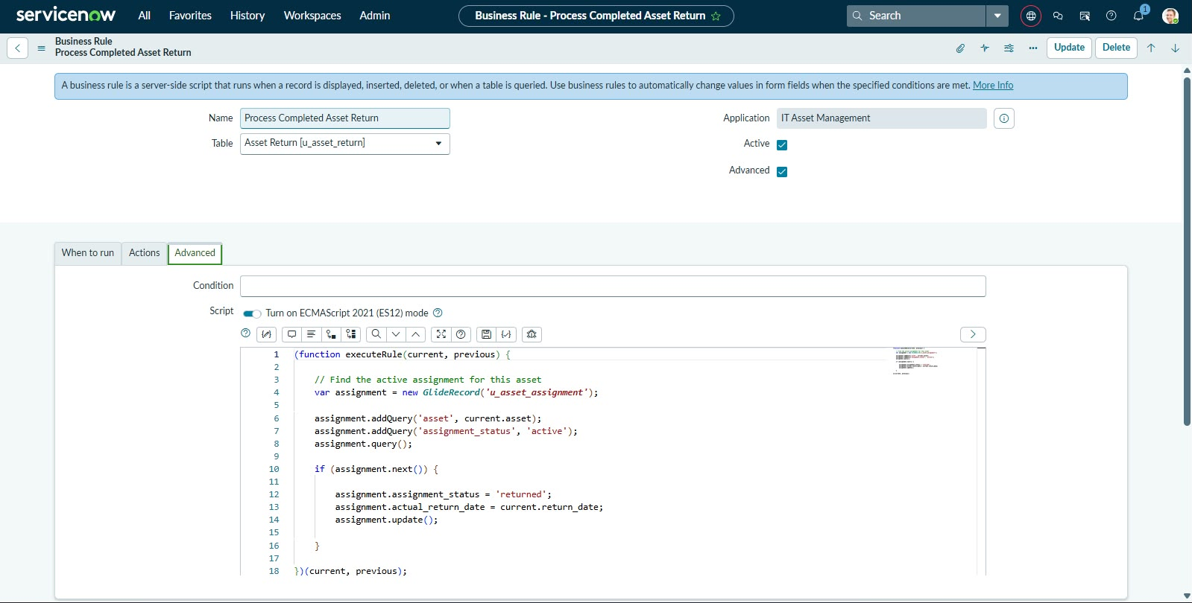
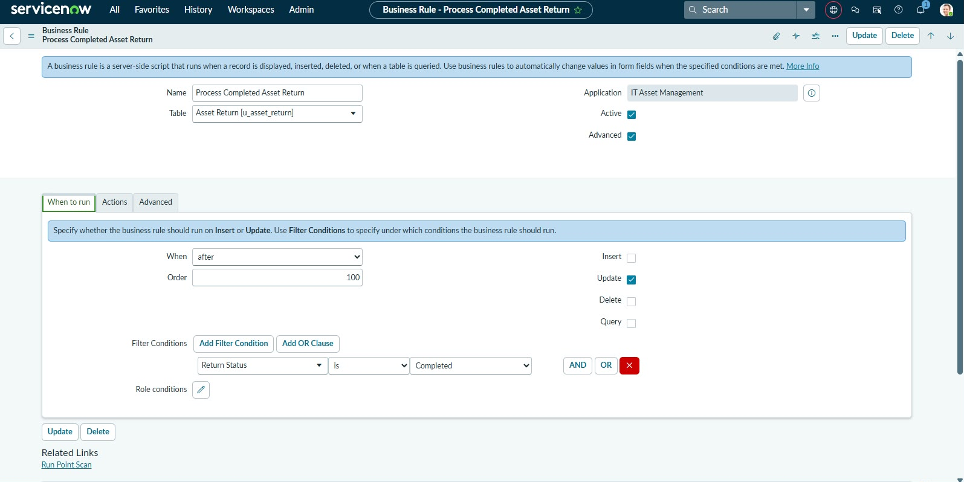
Ui policies
UI Policies control form fields based on specified conditions. They can make fields mandatory, read-only, or visible, helping improve form usability and data accuracy.
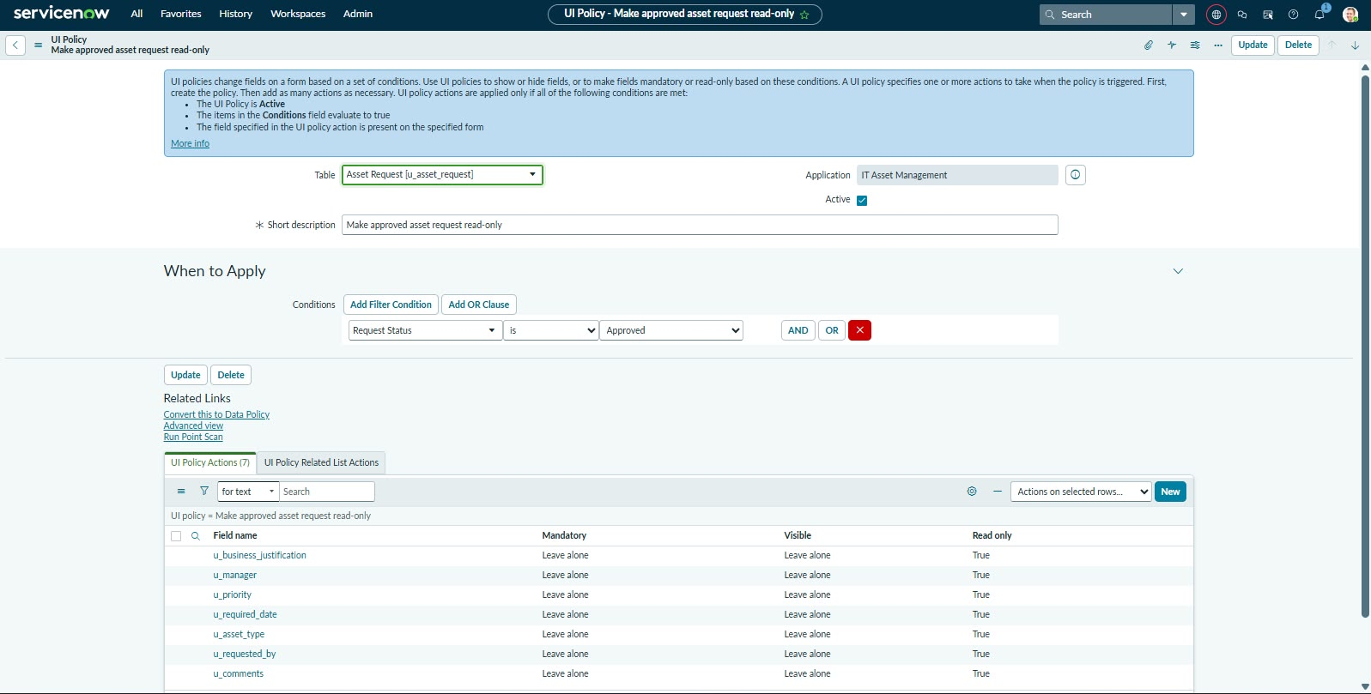

Roles and Access Control Rules
ACLs control access to tables, records, and fields in ServiceNow. In this project, ACLs and application roles help manage read and write permissions for administrators and standard users.

Client Scripts
Client Scripts validate user input and control form behaviour in the browser. In this project, an on Submit Client Script validates the required date and prevents submission when the selected date is in the past.
